The Green House – Junior Sous Chef

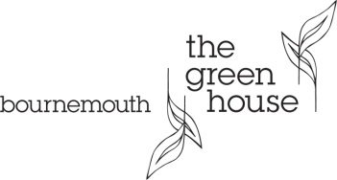

Junior Sous Chef
The Green House is a beautiful eco-friendly boutique hotel that lives, eats and breathes sustainability. Just minutes from the white sandy beaches of Bournemouth, this privately owned Grade II Victorian Villa has been extensively renovated with an investment in excess of £5m, to prove that luxury travel and eco-consciousness can co-exist. We are committed to sustaining an exceptional product coupled with exceptional service.
Arbor restaurant currently holds 2 AA Rosettes, Gold Award from Dorset Tourism Eating Out and the Environmental Award 2015 from the Sustainable Restaurant Association; whilst the hotel is proud to be awarded the Dorset Tourism Gold for Sustainable Tourism 2014, Considerate Hotel of the Year 2013-2014 and AA Eco Hotel of the Year 2013.
Reports directly to: Head Chef
Successful candidates will need to:
- Be passionate about food and be able to channel this into what customers want
- Be excited to work with fresh and local produce
- Achieve budget revenues through understanding the clients and their needs
- Work closely with the team to ensure all costs and payroll targets are achieved
- Be involved in the operation of the hotel and be a key player in the team
- Manage and develop and build a kitchen team
- Have excellent communication skills to include all departments
- Be enthusiastic, passionate with a positive attitude
- Have proven track record in reputable restaurants
Personality of the Arbor kitchen brigade:
- Passionate
- Creative and enthusiastic
- Environmentally conscious
- Recognises the importance of each guest
- Sees opportunities instead of stumbling blocks
- Adaptable
- Flexible
- Team player
- Excellent interpersonal skills
If you would like to join the team please send your CV with a covering letter

